COMPUTER SCIENCE PROJECT

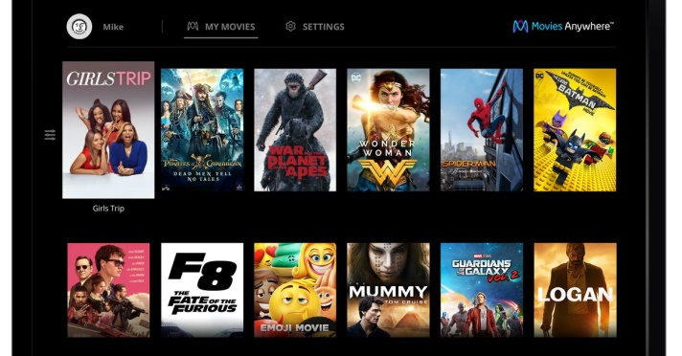BLOCKBUSTERS







Done By

**Vriksha Srihari**

XII – F1

February, 2019



**ACKNOWLEDGEMENT**

I would like to express my heartfelt gratitude to **Mrs. Latha**, my Computer Science teacher, without whose valuable inputs, the project could not have been completed. I would also like to thank **Mrs. Radhika** of Computer Science Department, who constantly helped me while doing this project. I would also like to thank our school management for providing us with excellent lab facilities and above all, CBSE, for providing us this great opportunity to explore C++.

**INDEX PAGE**

|  |  |  |
| --- | --- | --- |
| **S No** | **TOPIC** | **Page No** |
| 1 | Program Analysis | 1 |
| 2 | File Format | 2 |
| 3 | Source Code | 4 |
| 4 | Sample Output | 11 |
| 5 | Scope of the Project | 15 |
| 6 | Limitations | 16 |
| 7 | Bibiliography | 17 |

**Program analysis**

**Struct movie:** It is a structure whose objects are stored as records in the binary files ‘tamil.dat’ and ‘english.dat’. It contains data members no (movie no.), name(movie name), rating, h, s, review, and avgrat (average rating). It contains the following member functions:

|  |  |
| --- | --- |
| **Member Functions** | |
| Void output() | Displays the movie number and the movie name of a ‘movie record’ |
| Void calcavg() | Calculates the highest and the lowest rating for a movie. It also calculates the average rating of a movie |
| Void displayrev() | Displays all the reviews given to a movie |
| Void displayrat() | Displays the movie number and movie name along with its average, highest and lowest ratings. |

|  |  |
| --- | --- |
| **Other Functions** | |
| Void welcome() | Displays the welcome page to the user |
| Int language() | Displays the choice of languages available to the user and accepts & returns the choice(to main) |
| Int DisplayMovie(int op) | Displays all the movies present in a file by invoking output(). It takes the option number (‘No’) as a parameter to access the right binary file |
| Void displayRatings(int op) | Displays the average, highest and lowest rating for all the movies so that the user can compare and make informed decisions. It invokes calcavg() and displayrat() for every movie. It takes the option number (‘No’) as a parameter so as to open the right language file |
| Void newRatings(int op, int mno) | Accepts a new rating for the chosen movie from the user and makes necessary changes in that movie record. It takes option number and movie number as parameters to select the right file and search for the right movie |
| Void viewReview(int op, int mno) | Displays all the reviews for the chosen movie by invoking displayrev(). It takes option number and movie number as parameters to select the right file and search for the right movie. |
| Void writeReview(int op, int mno) | Accepts a new review for the chosen movie from the user and makes the necessary changes in that movie record. It takes option number and movie number as parameters to select the right file and search for the right movie |
| Void goodbye() | Displays the ‘goodbye’ page to the user and exits the program |

**File Format**

**Tamil.Dat**

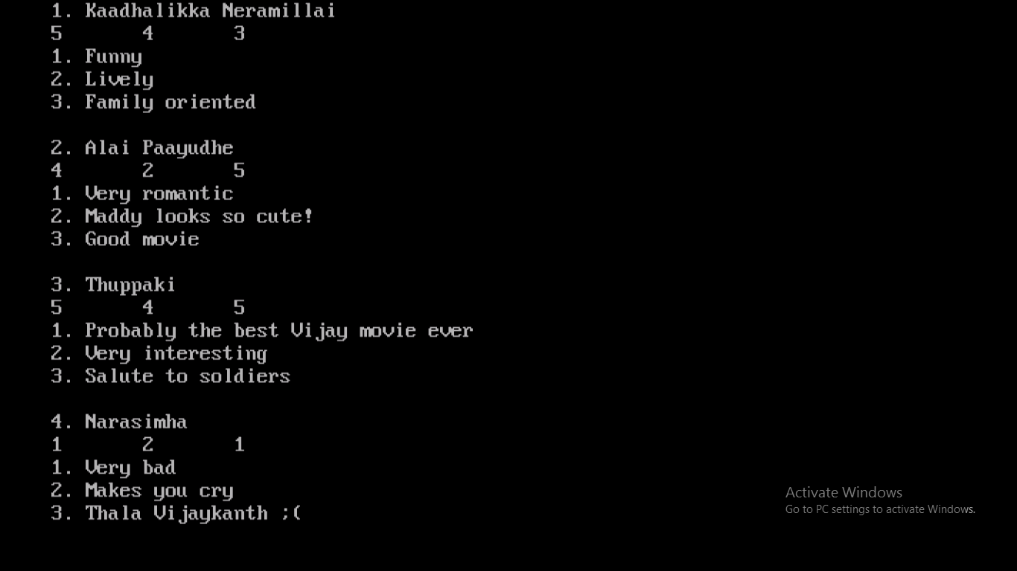

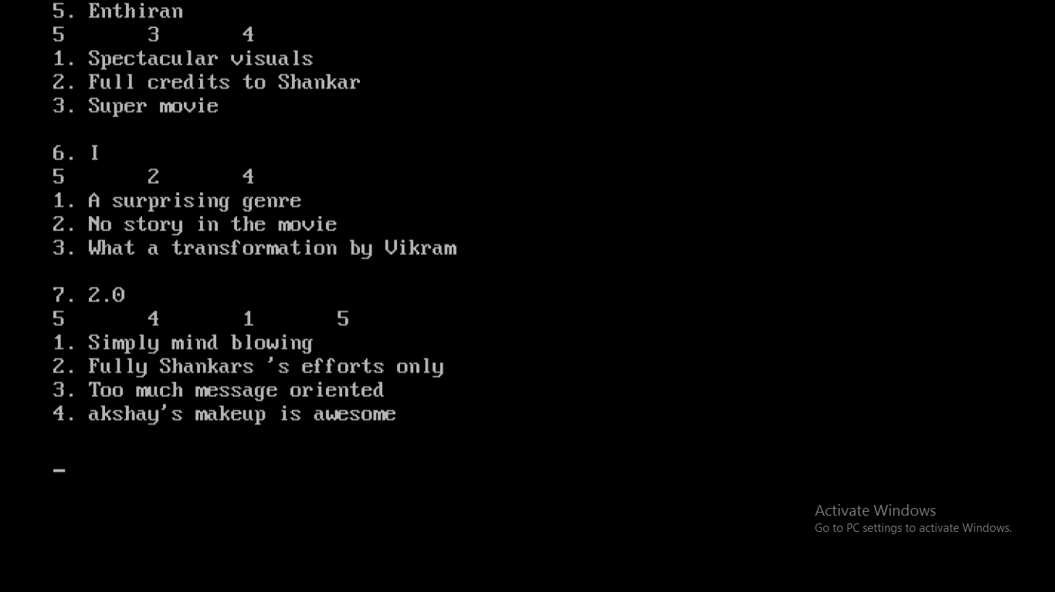

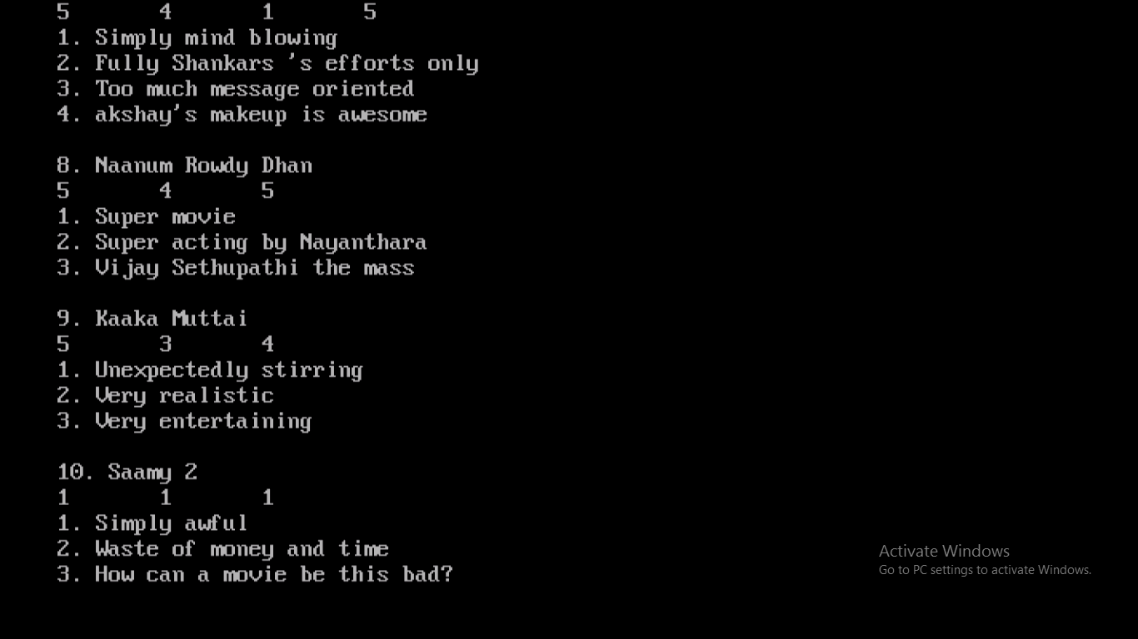

**English.Dat**

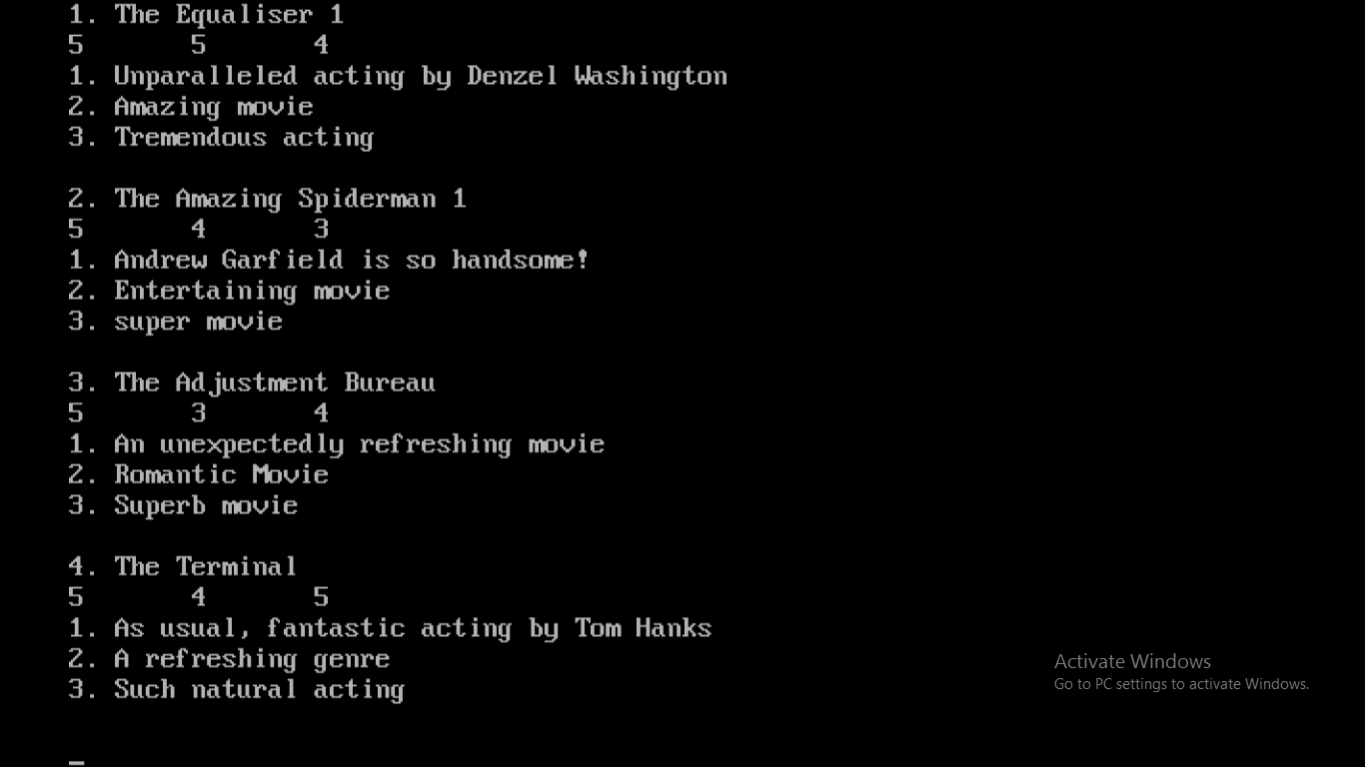

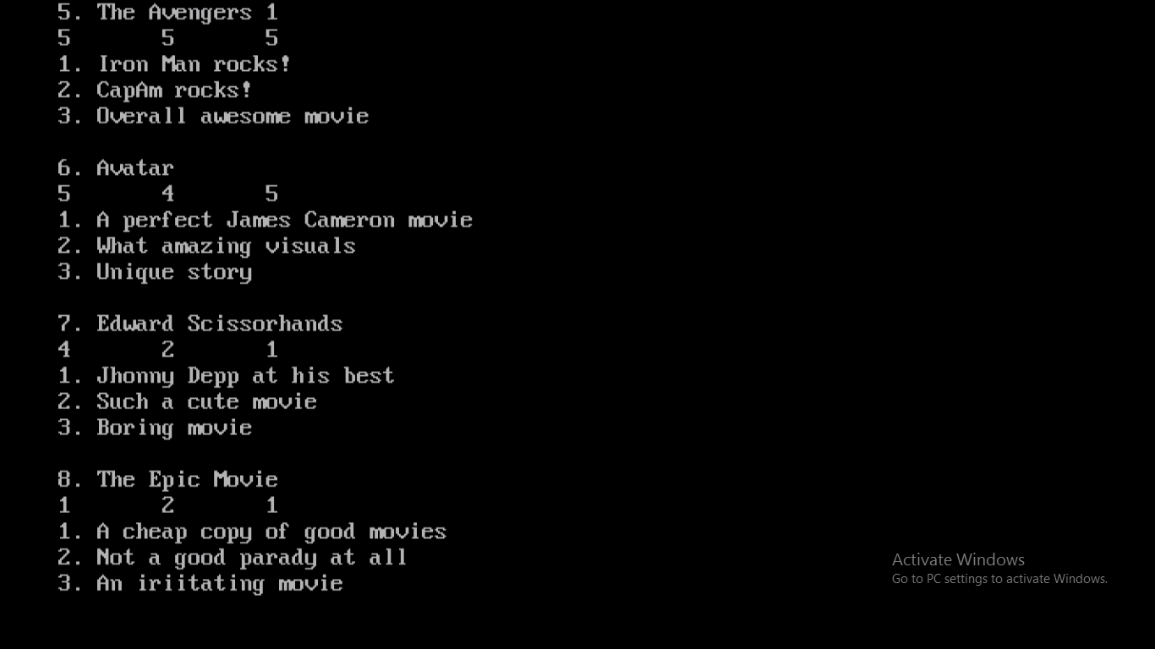

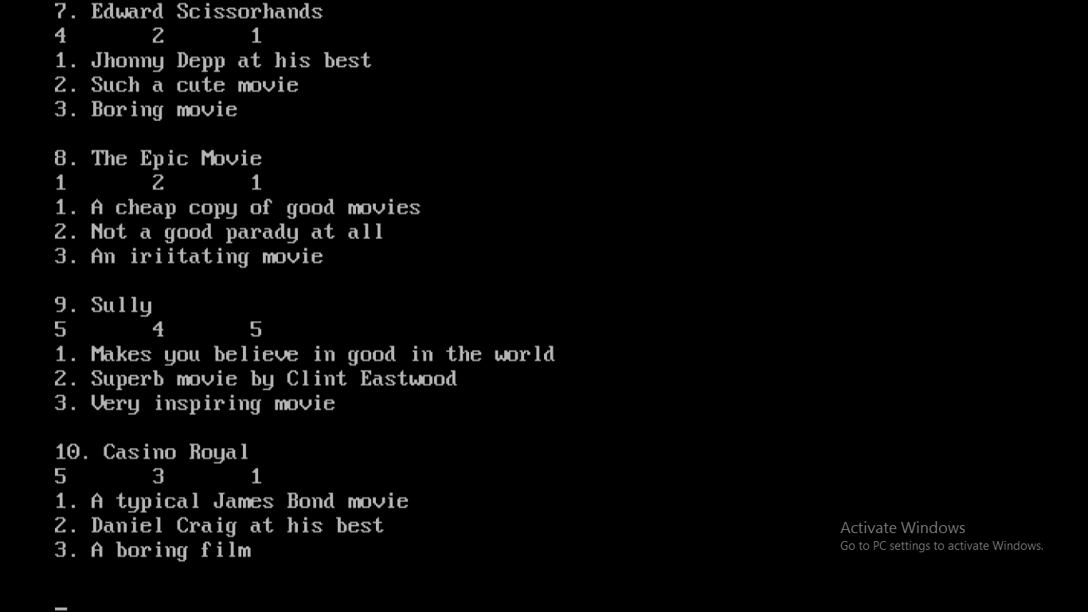

**Source Code**

//******************************************************

// This program displays ratings from

// reviewers, lets the user select a menu option,

// then performs ratings calculations and displays

// ratings analytics.

//******************************************************

#include<fstream.h>

#include<string.h>

#include<iomanip.h>

#include<conio.h>

#include<graphics.h>

#include<process.h>

#include<stdio.h>

#include<dos.h>

#include<stdlib.h>

struct movie

{

int no,rating[100],h,s;

char name[60], review[100][100];

float avgrat;

void output()

{ cout<<"\t\t"<<no<<". "<<name<<endl; }

void calcavg()

{

int i;

h=s=rating[0];

for(i=0;rating[i]!=0;i++)

{

if(rating[i]>=h)

h=rating[i];

if(rating[i]<=s)

s=rating[i];

}

int sum,flag=0;

for( i=0;rating[i]!=0;i++)

{ sum+=rating[i];

flag++; }

avgrat=sum/flag;

}

void displayrev()

{

cout<<"The reviews for "<<name<<" are: "<<endl;

for(int i=0;strcmpi(review[i],"0")!=0;i++)

cout<<i+1<<". "<<review[i]<<endl;

cout<<endl;

}

void displayrat()

{

cout<<"\t\t"<<setw(4)<<no<<" "<<setiosflags(ios::left)<<name/*<<" "*/<<setw(25-strlen(name))<<setiosflags(ios::right)<<avgrat<<setw(10)<<setiosflags(ios::right)<<h<<setw(10)<<setiosflags(ios::right)<<s<<endl;

}

};

void welcome();

int language();

void displayRatings(int op);

void newRatings(int op,int mno);

void viewReview(int op,int mno);

void writeReview(int op,int mno);

void goodbye();

int DisplayMovie(int op)

{

clrscr(); cleardevice();

int mno;

fstream f;

if(op==1)

f.open("tamil.dat ",ios::in|ios::out|ios::binary);

else

f.open("english.dat ",ios::in|ios::out|ios::binary);

cout<<"\t\tMOVIE LIST\n"<<endl;

movie t;

f.seekg(0);

f.read((char*)&t,sizeof(t));

while(!f.eof())

{

t.output();

f.read((char*)&t,sizeof(t));

}

f.close();

cout<<"\t\tEnter your option (1-10): ";

cin>>mno;

if(mno<1||mno>10)

{ cout<<"\t\tInvalid entry. Enter again."<<endl;

cin>>mno;

}

return mno;

}

void main()

{

clrscr();

int gdriver = DETECT, gmode, errorcode;

initgraph(&gdriver, &gmode, "c:\\turboC3\\bgi");

welcome();

int choice;

function2: //for changing language preference

int op,mno;

op=language();

// setbkcolor(15); setcolor(1);

//for changing movie pref. but same language

function1:

mno=DisplayMovie(op);

// user choice of menu options

while(1)

{

clrscr(); cleardevice();

setbkcolor(6);

//program interface with menu options

cout<<"\n\n\n\n\n\t\t---------------------------------------------------"<<endl;

cout<<"\t\tHey Perry, what shall we do today?"<<endl;

cout<<"\t\t---------------------------------------------------"<<endl;

cout<<"\t\t1. View highest, lowest and average rating for all the movies"<<endl;

cout<<"\t\t2. Enter new rating for chosen movie"<<endl;

cout<<"\t\t3. View reviews for chosen movie"<<endl;

cout<<"\t\t4. Write new review for chosen movie"<<endl;

cout<<"\t\t5. Choose another movie of the SAME language"<<endl;

cout<<"\t\t6. Change language preference"<<endl;

cout<<"\t\t7. Quit program"<<endl;

cout<<"\t\t---------------------------------------------------"<<endl;

cout<<endl<<"\t\tEnter your choice: ";

cin>>choice;

cout << endl;

switch (choice)

{

case 1 : displayRatings(op);

break;

case 2 : newRatings(op,mno);

break;

case 3 : viewReview(op,mno);

break;

case 4 : writeReview(op,mno);

break;

case 5 : goto function1;

break;

case 6 : goto function2;

break;

case 7 : goodbye();

break;

default : cout << "Please enter a choice from 1 to 7. ";

}

}

}

void welcome()

{

clrscr();

int gdriver=DETECT, gmode, errorcode;

char msg[][50]={"Welcome to ","Blockbusters"};

initgraph(&gdriver, &gmode, "c:\\turboC3\\bgi");

setbkcolor(11);

for(int i=0;i<400;i+=20)

{

//cleardevice();

settextstyle(4,0,7);

setcolor(8);

outtextxy(170, 100, msg[0]);

settextstyle(4,0,9);

setcolor(8);

outtextxy(80, 200, msg[1]);

setcolor(i);

rectangle(getmaxx()/2-269,getmaxy()/2-189,getmaxx()/2+269,getmaxy()/2+189);

rectangle(getmaxx()/2-279,getmaxy()/2-199,getmaxx()/2+279,getmaxy()/2+199);

setcolor(i+2);

settextstyle(3,0,3);

outtextxy(220, 380, "<<< Let's Go >>>");

delay(500);

}

getch();

}

int language()

{

clrscr();

int gdriver=DETECT, gmode, errorcode;

int op; char ans[2];

char msg[]="Choose A Language";

initgraph(&gdriver, &gmode, "c:\\turboC3\\bgi");

setbkcolor(12);

settextstyle(5,0,5);

setcolor(8);

outtextxy(120, 100, msg);

setcolor(1);

settextstyle(4,0,3);

outtextxy(120, 200, "1.Tamil");

setcolor(1);

settextstyle(4,0,3);

outtextxy(320, 200, "2.English");

setcolor(2);

settextstyle(1,0,3);

outtextxy(120, 300, "Choose an option(1/2): ");

ans[0]=getch();

ans[1]='\0';

outtextxy(400,300,ans);

op=atoi(ans);

getch();

return op;

}

void displayRatings(int op)

{

clrscr(); cleardevice();

fstream f;

if(op==1)

f.open("tamil.dat",ios::in|ios::out|ios::binary);

else

f.open("english.dat",ios::in|ios::out|ios::binary);

f.seekg(0);

movie t;

f.read((char*)&t,sizeof(t));

cout<<"\n\n\n\t\t"<<setw(62)<<setfill('-')<<" "<<endl;

cout<<"\t\t"<<setw(62)<<setfill(' ')<<" "<<endl;

cout<<"\t\t"<<"Movie Movie Average Highest Lowest"<<endl;

cout<<"\t\t"<<"No. Name Ratings Rating Rating"<<endl;

cout<<"\t\t"<<setw(62)<<setfill('-')<<" "<<endl;

cout<<"\t\t"<<setw(62)<<setfill(' ')<<" "<<endl;

while(!f.eof())

{

t.calcavg();

t.displayrat();

f.read((char*)&t,sizeof(t));

}

f.close();

getch();

}

void newRatings(int opt, int mno)

{

movie t,x; fstream f1;

char rev[1000]; int i,rat;

if(opt==1)

f1.open("tamil.dat",ios::in|ios::out|ios::binary|ios::ate);

else

f1.open("english.dat",ios::in|ios::out|ios::binary|ios::ate);

f1.seekg(0);

f1.read((char*)&t,sizeof(t));

while(!f1.eof())

{

if(t.no==mno)

{

x=t;

cout<<"\t\tEnter your ratings for "<<t.name<<" (from 1-5 only): " ;

cin>>rat;

if(rat<1||rat>5)

{ cout<<"\t\tInvalid entry. Please rate only from 1-5 "<<endl;

cin>>rat;}

for(i=0;t.rating[i]!=0;i++);

x.rating[i]=rat;

f1.seekp(f1.tellg()-sizeof(t));

f1.write((char*)&x,sizeof(x));

break;

}

f1.read((char *)&t,sizeof(t));

} f1.close();

cout<<"\n\t\tThank You! Your rating has been noted!"<<endl;

getch();

}

void viewReview(int opt, int mno)

{

movie t; fstream f1;

if(opt==1)

f1.open("tamil.dat",ios::in|ios::out|ios::binary);

else

f1.open("english.dat",ios::in|ios::out|ios::binary);

f1.seekg(0);

f1.read((char*)&t,sizeof(t));

while(!f1.eof())

{

if(t.no==mno)

{ t.displayrev();

break; }

f1.read((char*)&t,sizeof(t));

}

f1.close();

getch();

}

void writeReview(int opt, int mno)

{

movie t,x; fstream f1;

char rev[1000]; int i;

if(opt==1)

f1.open("tamil.dat",ios::in|ios::out|ios::binary|ios::ate);

else

f1.open("english.dat",ios::in|ios::out|ios::binary|ios::ate);

f1.seekg(0);

f1.read((char*)&t,sizeof(t));

while(!f1.eof())

{

if(t.no==mno)

{

x=t;

cout<<"\t\tEnter new review for "<<t.name<<endl;

gets(rev);

for(i=0;strcmpi(t.review[i],"0")!=0;i++);

strcpy(x.review[i],rev);

f1.seekp(f1.tellg()-sizeof(t));

f1.write((char*)&x,sizeof(x));

break;

}

f1.read((char*)&t, sizeof(t));

} f1.close();

cout<<"\n\t\tThank You! Your review has been noted!"<<endl;

getch();

}

void goodbye()

{

clrscr();

int gdriver=DETECT, gmode, errorcode;

int bkcol, maxcolor, x, y;

char msg[]="Hasta la Vista, Baby ;D";

initgraph(&gdriver, &gmode, "c:\\turboC3\\bgi");

setbkcolor(4);

for(int i=0;i<18;i++)

{

setcolor(15);

circle(50*i,50,50);

settextstyle(2,0,10);

setcolor(11);

outtextxy(60, 200, msg);

setcolor(15);

circle(50*i,getmaxy()-50,50);

delay(400);

}

exit(0);

}

**Sample Output**



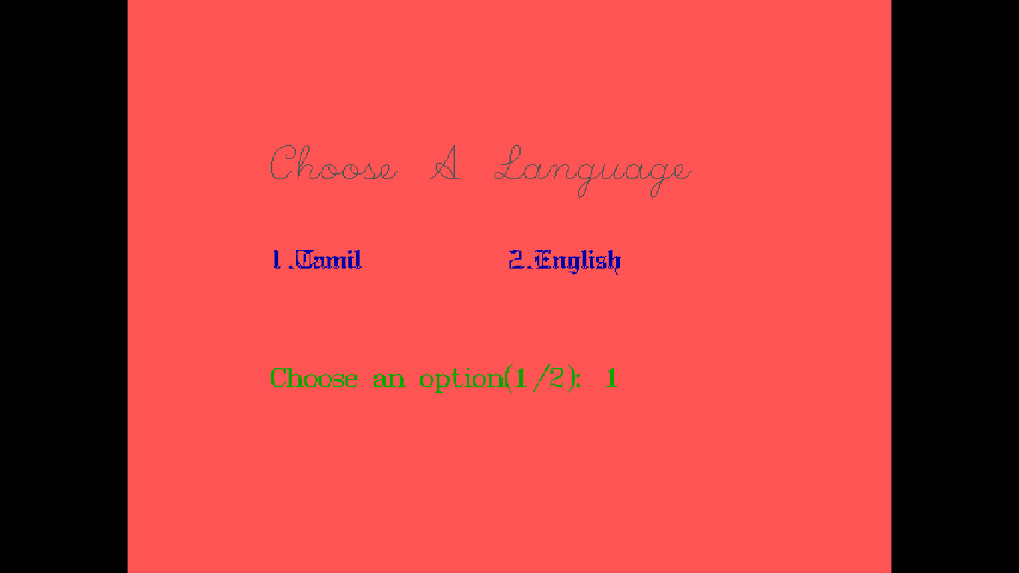

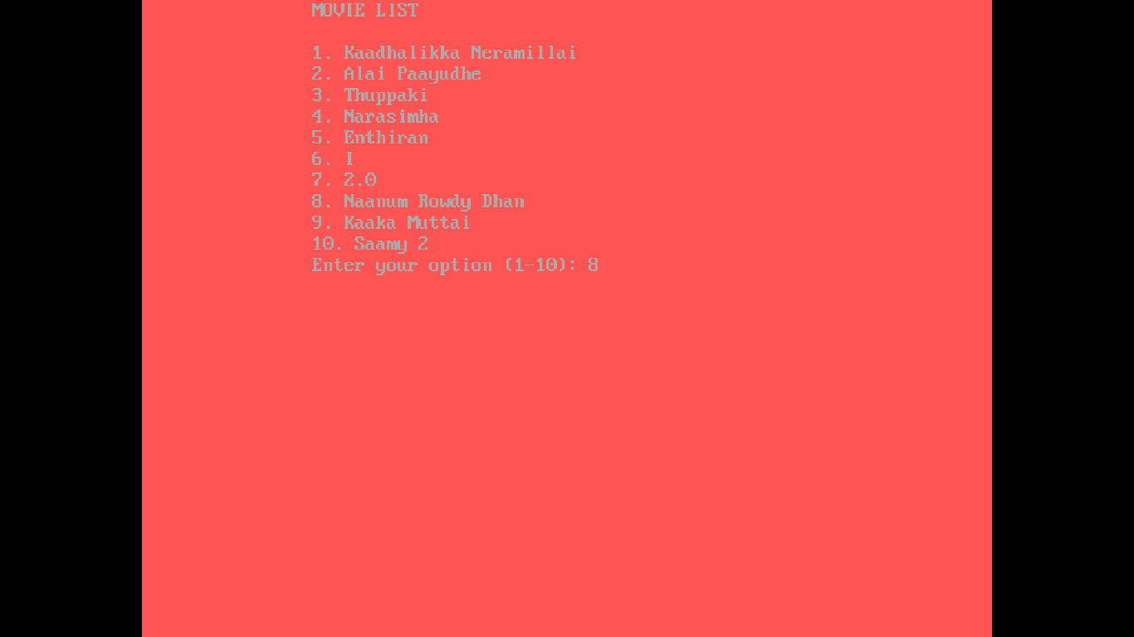

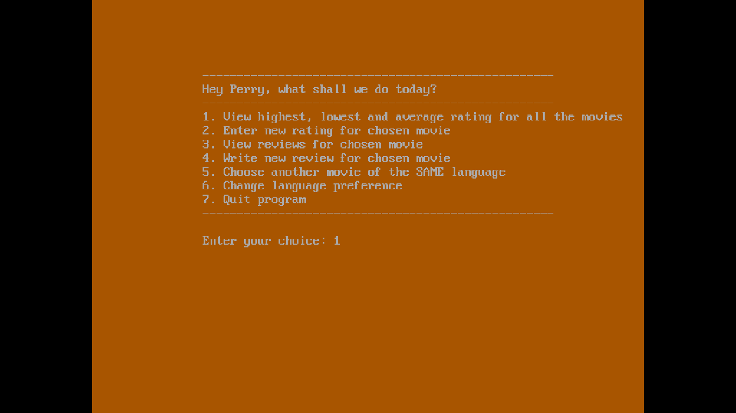

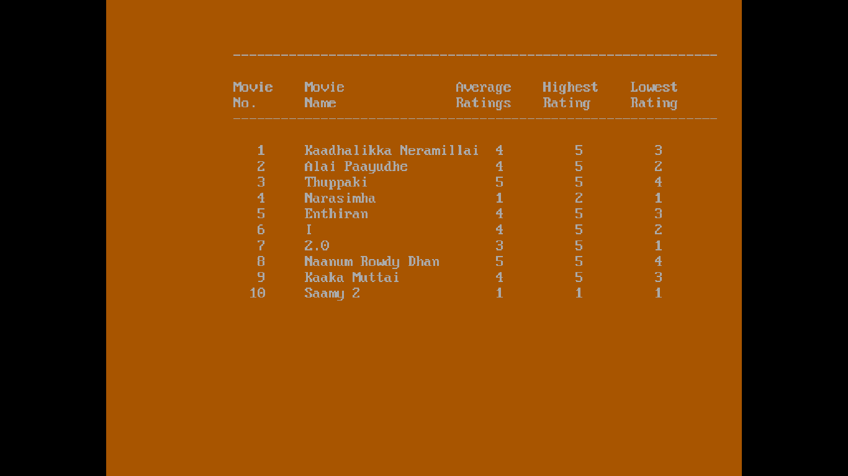

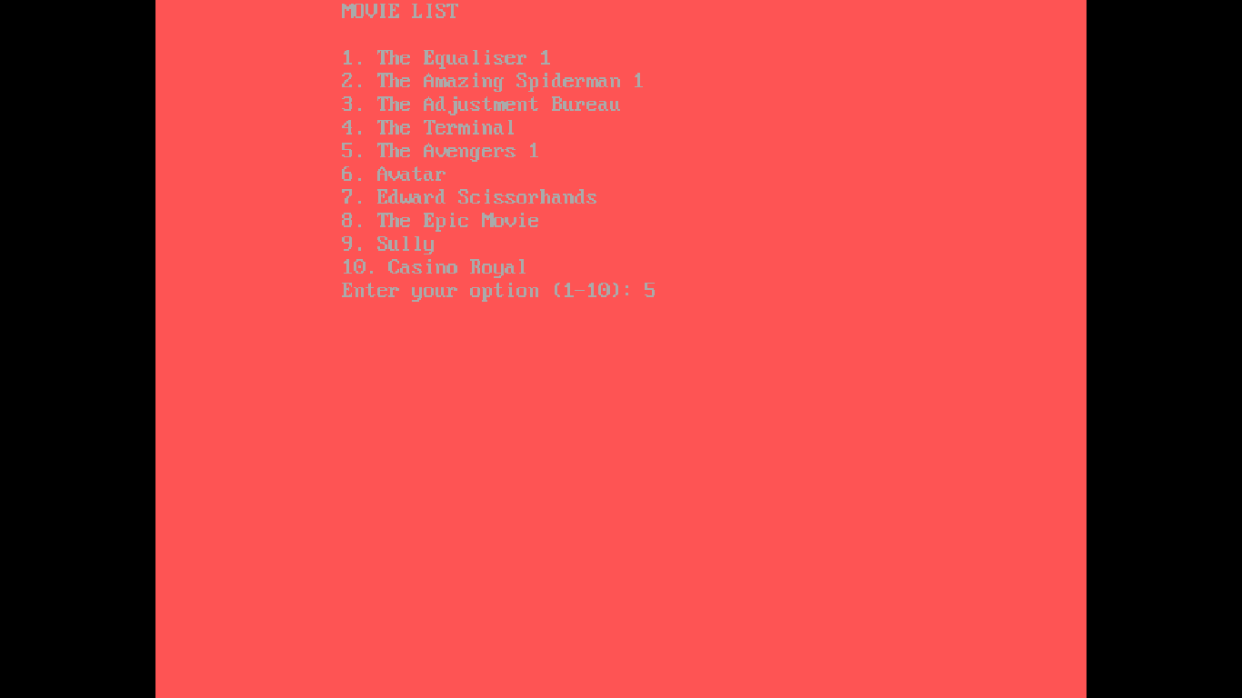

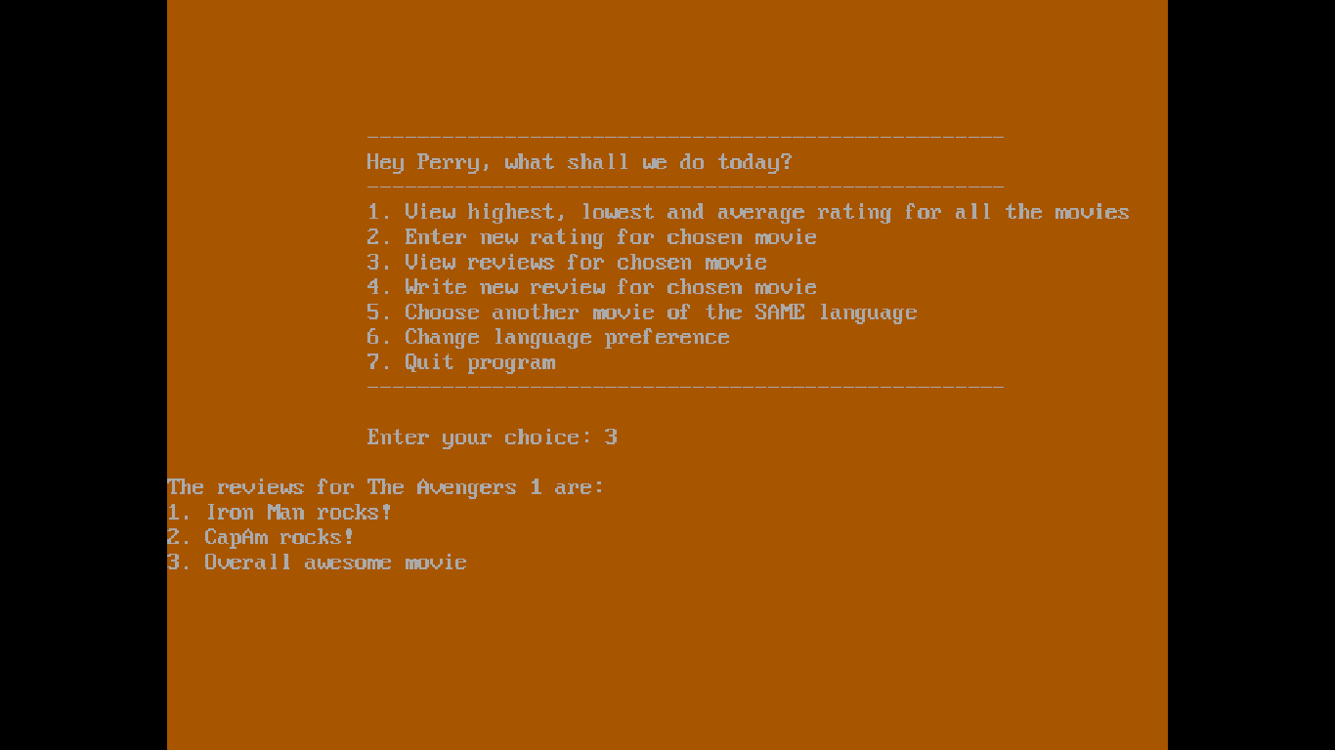

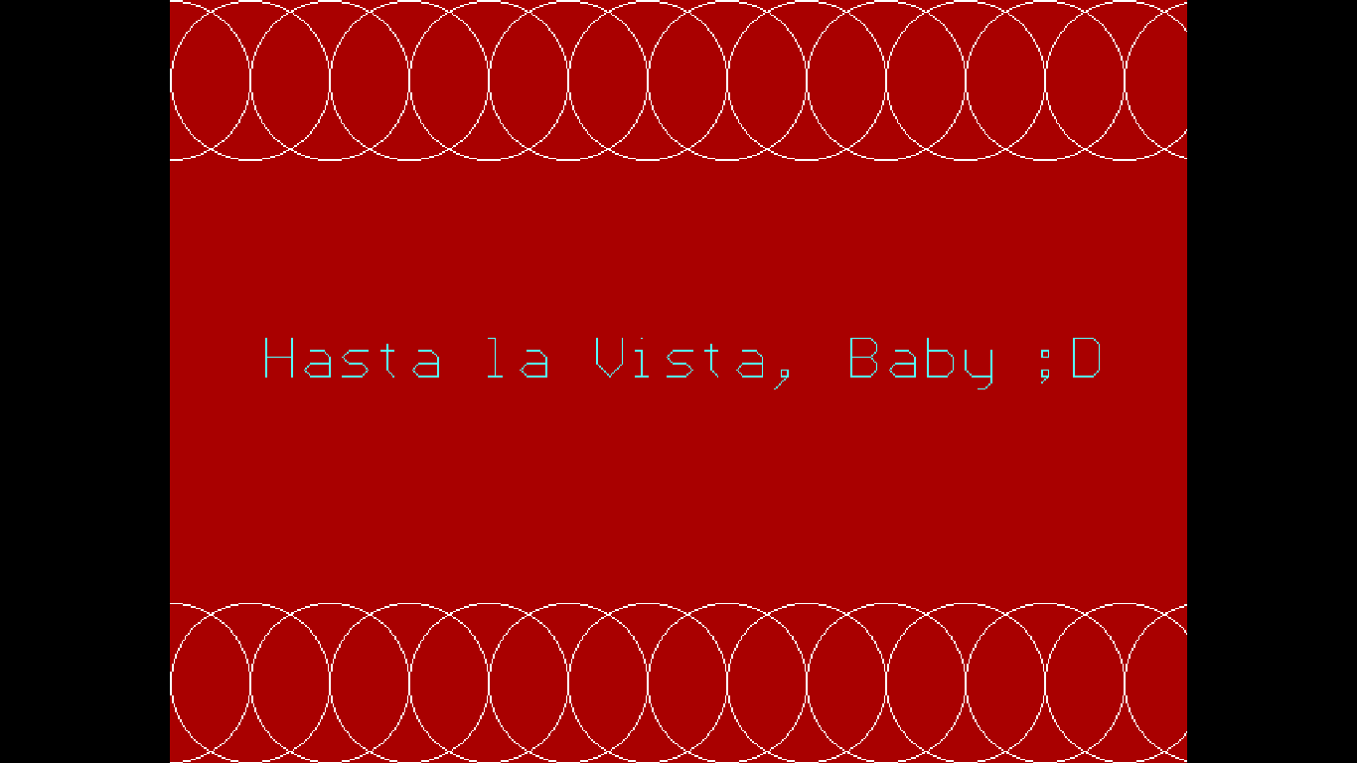

**Scope of the Project**

This program can be used to compare different movies based on the reviews and ratings got by each movie. By seeing the relative position of each movie with respect to one other, the user can make informed choices about which movie to see.

Another feature offered by this program is that the user themselves can give their reviews and ratings for a movie. Accordingly, the average, highest and the lowest ratings for that movie will be modified. The review will be added to the movie’s list of reviews.

This menu driven program offers the following choices to the user:

1. View average, highest and lowest rating for all movies.
2. Give rating for chosen movie.
3. View reviews for chosen movie.
4. Give review for chosen movie.
5. Choose another movie of same language.
6. Change language preference
7. Exit program

For both English and Tamil movies.

**Limitations**

* More languages can be added to widen the users’ available choices.
* More movies can be added under each language.
* An account based system for each user could be developed. This can be used to track a user’s activity in the site and provide suitable recommendations to the user during future visits.
* The menu options could be widened to access more information about the movies.

**Bibliography**

1. Computer Science with C++ by Sumita Arora, Volume 1, Textbook XII, 11th Edition.
2. <https://www.google.co.in/search?source=hp&ei=GsgYXI7yJYq8vwSHpYbIDA&q=how+to+do+graphics+in+c%2B%2B&btnK=Google+Search&oq=how+to+do+graphics+&gs_l=psy-ab.3.0.0l10.12133.41473..44103...8.0..0.112.2140.24j2......0....1..gws-wiz.....6..35i39j0i131.NlLiHtuFI1U>